TASK 1

Web Application QA Report
RealWorld Demo
Tester: Janhavi Rathod
Application: https://demo.realworld.show/
Assessment: Automation & QA Developer Take-Home

1. Testing Overview
This report documents usability, account-security, and article-management behaviours observed while exploring the RealWorld demo application. Testing focused on sign-up, account settings, article creation, article publication dates, and behaviour after logout.
The findings below distinguish directly observed behaviour from suspected causes. A suspected cause is a hypothesis until confirmed through application logs, API responses, or database inspection.

2. Bug Reports

Bug #1: Missing validation feedback when submitting an empty sign-up form
Module | User Registration / Sign Up
Precondition | The user is on the Sign Up page.
Steps to reproduce | 1. Open the Sign Up page.  2. Leave all input fields empty.  3. Click Sign Up.  4. Observe the form response.
Expected result | The form should identify required fields and display clear inline validation messages or an accessible summary explaining what the user must correct.
Actual result | Submission is blocked, but no clear validation message is displayed. The cursor changes to a blocked state.
Severity | Low — usability / validation feedback
Suspected cause | Required-field validation may prevent submission without displaying an associated message. This should be confirmed by inspecting the form validation and error-rendering behaviour.
Status | Confirmed observation

Bug #2: Password change may not require current-password verification
Module | Settings / Account Security
Precondition | The user is logged in and can access account settings.
Steps to reproduce | 1. Log in.  2. Open Settings.  3. Enter a new password without entering the existing password.  4. Submit the form.  5. Verify whether the password changes.
Expected result | The application should enforce an appropriate account-verification step before changing credentials, such as current-password verification or a suitable re-authentication mechanism.
Actual result | Confirmed. Record the exact response after completing the test. Do not report this as a confirmed security defect until the password change succeeds without an appropriate verification mechanism.
Severity | Provisional: Medium — potential account-security issue
Suspected cause | The password-update flow may not enforce re-authentication. This is only a hypothesis until the behaviour is verified and the relevant authentication controls are understood.
Status | Confirmed observation

Bug #3: Existing article publication dates appear to change after a new article is created
Module | Article Management / Publication Dates
Precondition | Multiple articles with previously established publication dates are available.
Steps to reproduce | 1. Open the article feed.  2. Record the displayed dates for existing articles.  3. Create and publish a new article.  4. Return to the feed.  5. Compare the displayed dates of the existing articles.
Expected result | Only the newly created article should receive a new publication timestamp. Existing articles should retain their original publication dates.
Actual result | The displayed publication dates of existing articles appear to update after a new article is created. It has not yet been established whether the underlying stored timestamps also change.
Severity | Medium — potential data-integrity / display issue
Suspected cause | The application may be updating timestamps on existing records, or the frontend may be displaying a shared or incorrectly mapped timestamp. Database or API inspection is needed to identify the source.
Status | Observed; root cause unconfirmed

Bug #4: User-created articles are no longer visible after logout
Module | Article Management / Authentication
Precondition | The user is logged in and has published at least one article.
Steps to reproduce | 1. Log in.  2. Create and publish an article.  3. Confirm that it appears in the user's profile.  4. Log out.  5. Open the public feed or the relevant profile.  6. Check whether the article remains accessible.
Expected result | Logging out should end the user's session only. Published articles should remain persisted and visible according to the application's access rules.
Actual result | The user's previously created articles are no longer visible after logout. Further checking is required to determine whether they are deleted, hidden by access rules, or simply not loaded in the logged-out view.
Severity | Provisional: High — potential data-persistence issue
Suspected cause | Article data may be incorrectly tied to session state, or the logged-out view may fail to retrieve or display persisted articles. Confirm persistence through the API or database before concluding that data is lost.
Status | Observed; persistence cause unconfirmed

3. Root Cause Analysis

Issue selected: Existing article publication dates appear to change
After a new article is published, previously created articles appear to show updated publication dates. This suggests that the date displayed for an article may not be tied consistently to that article's original creation time. One possible cause is that the article-creation process updates a timestamp across multiple records instead of only the new record. Another possibility is that the frontend uses a shared or incorrectly mapped date value when rendering the feed. The available observation does not establish which of these causes is responsible. I would compare the API responses for the existing articles before and after creating a new article, and inspect stored timestamps if database access is available. The backend should assign a creation or publication timestamp only to the newly created article and preserve timestamps on existing records. The frontend should render the timestamp belonging to each individual article. A regression test should verify that creating a new article does not change the displayed or stored publication dates of older articles.

4. Testing Summary
The exploratory checks identified issues or potential issues in sign-up validation feedback, password-change verification, article publication-date handling, and article visibility after logout. Some findings require additional verification to distinguish a confirmed defect from a suspected cause. Before release, the application should be tested for clear validation feedback, secure credential changes, consistent per-article timestamps, and persistence of published content across authentication-state changes.

Evidence 
Image 1: Bug #3: Existing article publication dates appear to change after a new article is created

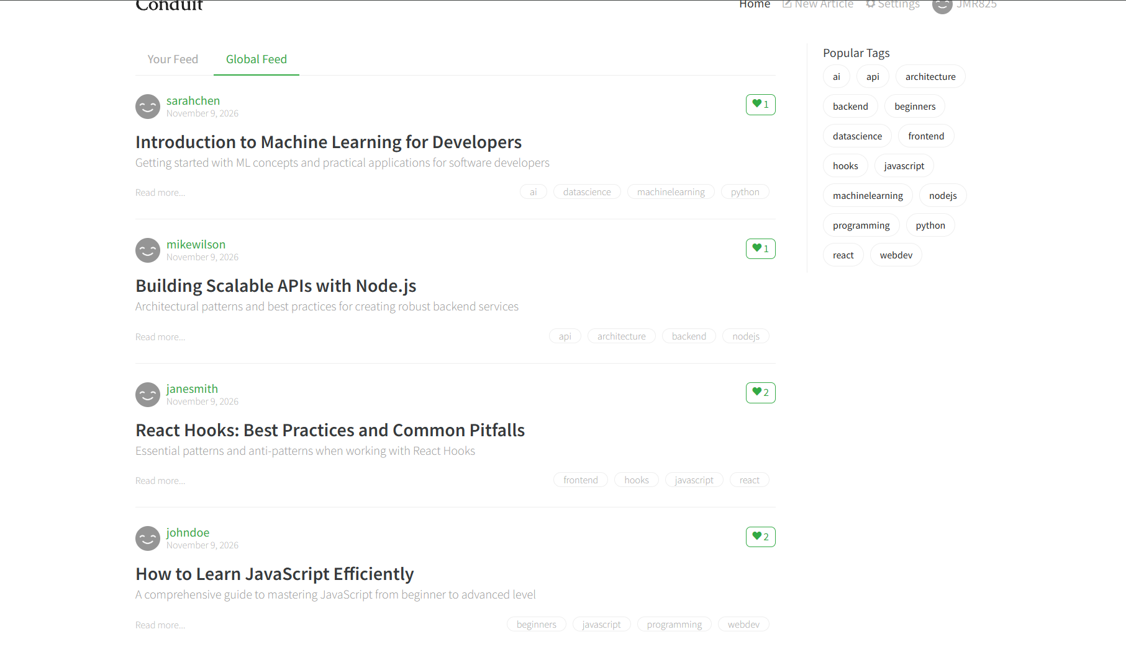
Bug #3: Existing article publication dates appear to change after a new article is created

